Xpath 语法

目录

odoo 开发基础 -- 视图之xpath语法 2

Using <xpath> in OpenERP/ odoo 10

XPATH INSIDE NOTEBOOK PAGE –ODOO 11

How can I remove “Powered by Odoo” on odoo 8.0 (OpenERP)? 11

# [**odoo 开发基础 -- 视图之xpath语法**](https://www.cnblogs.com/hellojesson/p/7126036.html)

odoo 视图函数 在整个项目文件中，结构并不是十分明显，虽然它也遵循MVC设计，类比django的MTV模式，各个模块区分的十分明显，在Odoo中，视图的概念不是特别明显，很多时候，我们会将调用模型的函数直接写在models里边（即：类中）。

而对于模版Tempelate部分，odoo里边反而称做“views”，如下是odoo典型模块，销售模块sale的代码结构：

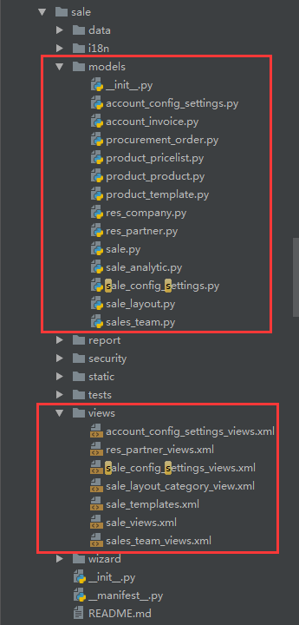

可以看到odoo的前端显示部分，对应的就是views，它是基于xml来实现的，而不是我们日常的html；

今天要说的xpath语法，就是针对于xml文件的一种语法格式。

通过xpath语法，可以对xml文件中要显示的内容，进行自定义的显示，比如：我们要插入一个新的标签在当前已经存在的标签的后边，前边，里边甚至替换。。。

这种语法看着还有点像JS的寻找父子节点。。。

1. xpath有一个用法，就是当你要修改的多个标签是在同一个目录节点下的时候，多个xpath标签可以写在同一个<record>标签中，而不用每次都去声明定义一遍，

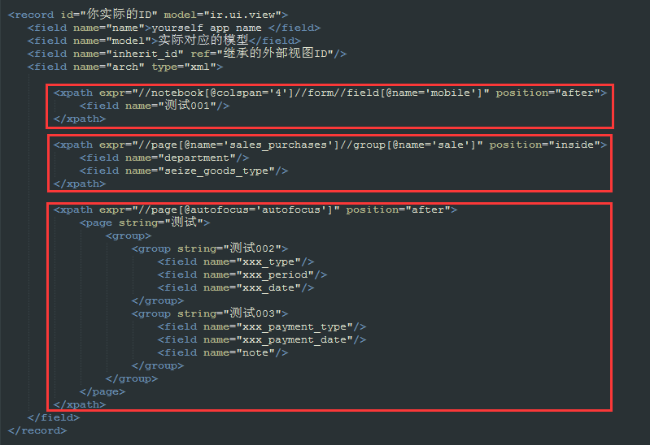

支持的视图类型：form、tree、search ...

支持的定位方法：

<notebook position="inside">

　　　　　 <xpath expr="//page[@name='page_history']" position="inside">

<field name="mobile" position="after">

<filter name="consumable" position="after">

<group name="bank" position="after">

<xpath expr="//field[@name='standard_price']" position="replace">

<xpath expr="//button[@name='open_ui']" position="replace">

<xpath expr="//div[@class='oe_employee_details']/h4/a" position="after">

<xpath expr="/form/sheet/notebook/page/field[@name='line_ids']/tree/field[@name='analytic_account_id']" position="replace">

<xpath expr="/form/sheet/notebook/page/field[@name='line_ids']/form/group/field[@name='analytic_account_id']" position="replace">

支持的规则：before、after、replace、inside、attributes

插入：

position='before'  
position="after"

　　　　　 <field name="mobile" position="after">

　　　　　　　<field name="sale_order_count"/>

　　　　　 </field>

<filter name="consumable" position="after">

<separator/>

<filter name="filter_to_qty_available" string="在手数量>0" icon="terp-accessories-archiver+" domain="[('qty_available', '>', 0)]"/>

<filter name="filter_to_virtual_available" string="预测数量>0" icon="terp-accessories-archiver+" domain="[('virtual_available', '>', 0)]"/>

</filter>

替换：  
position="replace"

<xpath expr="//field[@name='standard_price']" position="replace">

<group name='cost_prices' colspan="2" col="4">

<field name="standard_price" nolabel="1" attrs="{'readonly':[('cost_method','=','average')]}"/>

<field name="cost_price_extra" groups="product.group_product_variant"/>

</group>

</xpath>

<xpath expr="//button[@name='open_ui']" position="replace">

<button name="open_ui" type="object" string="Start Selling" attrs="{'invisible' : [('pos_state', 'not in', ('opened',))]}" class="oe_highlight" invisible="True"/>

</xpath>

内部创建：position="inside"

<xpath expr="//page[@name='page_history']" position="inside">

<group name="grp_task" string="Tasks">

<field name="task_ids" colspan="4" nolabel="1">

<tree string="Tasks" editable="bottom">

<field name="name"/>

<field name="user_id"/>

<field name="date_deadline"/>

<field name="state" invisible="1"/>

<button name="do_open" states="pending,draft,done,cancelled" string="Start Task" type="object" icon="gtk-media-play" help="For changing to open state" invisible="context.get('set_visible',False)"/>

<button name="action_close" states="draft,pending,open" string="Done" type="object" icon="terp-dialog-close" help="For changing to done state"/>

</tree>

</field>

</group>

</xpath>

修改属性：修改属性能够实现的功能，不要使用 replace  
position="attributes"

<xpath expr="//field[@name='name']" position="attributes">

<attribute name="required">1</attribute>

</xpath>

示例代码：

<record id="product_normal_variant_form_view" model="ir.ui.view">

<field name="name">product.normal.variant.form</field>

<field name="model">product.product</field>

<field name="type">form</field>

<field name="inherit_id" ref="product.product_normal_form_view" />

<field name="arch" type="xml">

<data>

<xpath expr="//field[@name='name']" position="attributes">

<attribute name="required">1</attribute>

</xpath>

<xpath expr="//field[@name='standard_price']" position="replace">

<group name='cost_prices' colspan="2" col="4">

<field name="standard_price" nolabel="1" attrs="{'readonly':[('cost_method','=','average')]}"/>

<field name="cost_price_extra" groups="product.group_product_variant"/>

</group>

</xpath>

<sheet>

<group col="2" colspan="2" groups="base.group_extended" position="replace">

<group colspan="2" col="6" name="weight" groups="base.group_extended">

<field name="is_multi_variants" invisible="1"/>

<group colspan="2" col="2">

<separator string="Template Weights" colspan="2"/>

<field digits="(14, 3)" name="volume" attrs="{'readonly':[('type','=','service')]}"/>

<field digits="(14, 3)" name="weight" attrs="{'readonly':[('type','=','service')]}"/>

<field digits="(14, 3)" name="weight_net" attrs="{'readonly':[('type','=','service')]}"/>

</group>

<group colspan="2" col="2" attrs="{'invisible':[('is_multi_variants','=',False)]}">

<separator string="Variant Weights" colspan="2"/>

<field digits="(14, 3)" name="additional_volume" attrs="{'readonly':[('type','=','service')]}"/>

<field digits="(14, 3)" name="additional_weight" attrs="{'readonly':[('type','=','service')]}"/>

<field digits="(14, 3)" name="additional_weight_net" attrs="{'readonly':[('type','=','service')]}"/>

</group>

<group colspan="2" col="2" attrs="{'invisible':[('is_multi_variants','=',False)]}">

<separator string="Total Weights" colspan="2"/>

<field digits="(14, 3)" name="total_volume"/>

<field digits="(14, 3)" name="total_weight"/>

<field digits="(14, 3)" name="total_weight_net"/>

</group>

</group>

</group>

</sheet>

</data>

</field>

</record>

<!-- 隐藏 open_ui 按钮 -->

<record model="ir.ui.view" id="pos_session_opening_form_view_openui">

<field name="name">pos.session.opening.form.view.openui</field>

<field name="model">pos.session.opening</field>

<field name="inherit_id" ref="point_of_sale.pos_session_opening_form_view"/>

<field name="arch" type="xml">

<xpath expr="//button[@name='open_ui']" position="replace">

<button name="open_ui" type="object" string="Start Selling" attrs="{'invisible' : [('pos_state', 'not in', ('opened',))]}" class="oe_highlight" invisible="True"/>

</xpath>

</field>

</record>

<record id="product_search_form_view_filter" model="ir.ui.view">

<field name="name">product.search.form.filter</field>

<field name="model">product.product</field>

<field name="inherit_id" ref="product.product_search_form_view"/>

<field name="arch" type="xml">

<filter name="consumable" position="after">

<separator/>

<filter name="filter_to_qty_available" string="在手数量>0" icon="terp-accessories-archiver+" domain="[('qty_available', '>', 0)]"/>

<filter name="filter_to_virtual_available" string="预测数量>0" icon="terp-accessories-archiver+" domain="[('virtual_available', '>', 0)]"/>

</filter>

</field>

</record>

<!-- Partner kanban view inherte -->

<record model="ir.ui.view" id="crm_lead_partner_kanban_view">

<field name="name">res.partner.kanban.saleorder.inherit</field>

<field name="model">res.partner</field>

<field name="inherit_id" ref="base.res_partner_kanban_view"/>

<field name="priority" eval="20"/>

<field name="arch" type="xml">

<field name="mobile" position="after">

<field name="sale_order_count"/>

</field>

<xpath expr="//div[@class='oe_kanban_partner_links']" position="inside">

<a name="%(sale.act_res_partner_2_sale_order)d" type="action" t-if="record.sale_order_count.value>0">

<t t-esc="record.sale_order_count.value"/> Sales

</a>

</xpath>

</field>

</record>

<!-- Partners inherited form -->

<record id="view_task_partner_info_form" model="ir.ui.view">

<field name="name">res.partner.task.info.inherit</field>

<field name="model">res.partner</field>

<field name="inherit_id" ref="base.view_partner_form"/>

<field name="arch" type="xml">

<xpath expr="//page[@name='page_history']" position="attributes">

<attribute name="invisible">False</attribute>

</xpath>

<xpath expr="//page[@name='page_history']" position="inside">

<group name="grp_task" string="Tasks">

<field name="task_ids" colspan="4" nolabel="1">

<tree string="Tasks" editable="bottom">

<field name="name"/>

<field name="user_id"/>

<field name="date_deadline"/>

<field name="state" invisible="1"/>

<button name="do_open" states="pending,draft,done,cancelled" string="Start Task" type="object" icon="gtk-media-play" help="For changing to open state" invisible="context.get('set_visible',False)"/>

<button name="action_close" states="draft,pending,open" string="Done" type="object" icon="terp-dialog-close" help="For changing to done state"/>

</tree>

</field>

</group>

</xpath>

</field>

</record>

# Using <xpath> in OpenERP/ odoo

<template id="report_saleorder_document">

  <t t-call="report.external_layout">

    <div **class**="page">

      <h2>

        <span t-field="doc.name"/>

      </h2>

      <table **class**="table table-condensed">

        <thead>

          <tr>

            <th>Description</th>

            <th **class**="text-right">Quantity</th>

            <th **class**="text-right">Unit Price</th>

            <th t-**if**="display_discount" **class**="text-right"</th>

            <th **class**="text-right">Taxes</th>

            <th **class**="text-right" name="price_subtotal_head">Price</th>

          </tr>

        </thead>

      </table>

    </div>

  </t>

</template>

Using to add new label:

Option 1:

<xpath expr="//th[@name='price_subtotal_head']" position="after">

  <th **class**="text-right">New Label</th>

</xpath>

Option 2:

<xpath expr="//t/div/table/thead/tr/th[5]" position="after">

  <th **class**="text-right">New Label</th>

</xpath>

Option 3:

<xpath expr="//t/div/table/thead/tr/th[last()]" position="after">

  <th **class**="text-right">New Label</th>

</xpath>

# XPATH INSIDE NOTEBOOK PAGE –ODOO

Field inside page

<**xpath** expr="//page[@name='sales_purchases']//field[@name='customer']" position="before">

    <**field** name="prospect"/>

</**xpath**>

Page before existing page

<**xpath** expr="//page[@string='Other Info']" position="before">

    <**page** string="Bank Details">

        <**field** name="bank_details"/>

    </**page**>

</**xpath**>

# [How can I remove “Powered by Odoo” on odoo 8.0 (OpenERP)?](https://stackoverflow.com/questions/27731799/how-can-i-remove-powered-by-odoo-on-odoo-8-0-openerp)

down vote[favorite](https://stackoverflow.com/questions/27731799/how-can-i-remove-powered-by-odoo-on-odoo-8-0-openerp/27731929)

(OpenERP) ? 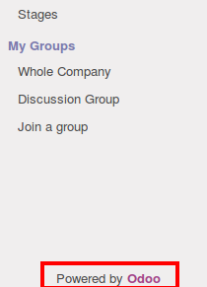

First go to your Odoo web module and open below file.

addons => web => views => webclient_templates.xml

Now find this tag <div class="oe_footer"> and put it comment like.

<!--div class="oe_footer">

Powered by <a href="http://www.openerp.com" target="_blank"><span>Odoo</span></a>

</div-->

Hope this will solved your problem.

You can extend QWEB template to remove it, create template.xml under static/xml/containing the following code:

<?xml version="1.0" encoding="utf-8"?>

<template xml:space="preserve">

<t t-extend="web.menu_secondary">

<t t-jquery="div.oe_footer" t-operation="replace"/>

</t>

</template>

**You can Inherit web module and apply below code.**

<template id="menu_secondary_replace" inherit_id="web.menu_secondary" name="Submenu">

<xpath expr="//div[@class='oe_footer']" position="replace">

<div class="oe_footer">

Powered by <a href="your website name" target="_blank"><span>Your String</span></a>

</div>

</xpath>

</template>

You can remove using jquery adding this script on document ready:

<script>

$(document).ready(function(){

$(".oe_footer").remove()

});

</script>

you can add this snipped in this file addons/website/static/src/js/website.js

 you can add the script to /web/static/src/js/views.js